Acute Gastrointestinal Bleeding: Recommended Imaging Protocol.

EGD and colonoscopy are currently considered the first line diagnostic and therapeutic procedures for both upper and lower GI bleeding. If endoscopy is unavailable or unsuccessful, imaging is often requested.

Noninvasive imaging with technetium 99m labeled RBC’s can be used to detect and localize GI bleeding. Radionuclide Imaging has a high sensitivity and specificity (93% and 95% respectively) (1). Radionuclide imaging, however, usually cannot adequately localize bleeding for catheter directed therapy/embolization.

In patients with unsuccessful endoscopy or if the radionuclide imaging study is positive, CT Angiography (CTA) is recommended, provided there is no contraindication such as chronic or acute renal disease. CTA, in the detection and localization of GI bleeding has an overall location based sensitivity, specificity, accuracy, positive predictive value, and negative predictive value of 90.9%, 99%, 97.6%, 95% and 98% respectively (2). If the CTA is positive, then catheter directed angiography can be performed for possible embolization. If CTA is negative catheter directed angiography should be deferred. Catheter directed angiography has a sensitivity of 63-90% and 40%-86% for upper and lower gastrointestinal bleeding respectively (3, 4). We also have reviewed recent cases where the arteriogram was negative for GI bleeding and the CTA was positive. Embolization was performed based on the CTA with good clinical outcomes.

The American College of Radiology (ACR) recommends this imaging protocol.

An informative article can be found in Radiographics, September 2013, which addresses the use of CTA for acute GI bleeding. This article gives the following flow chart for work up of acute GI bleeding (5).

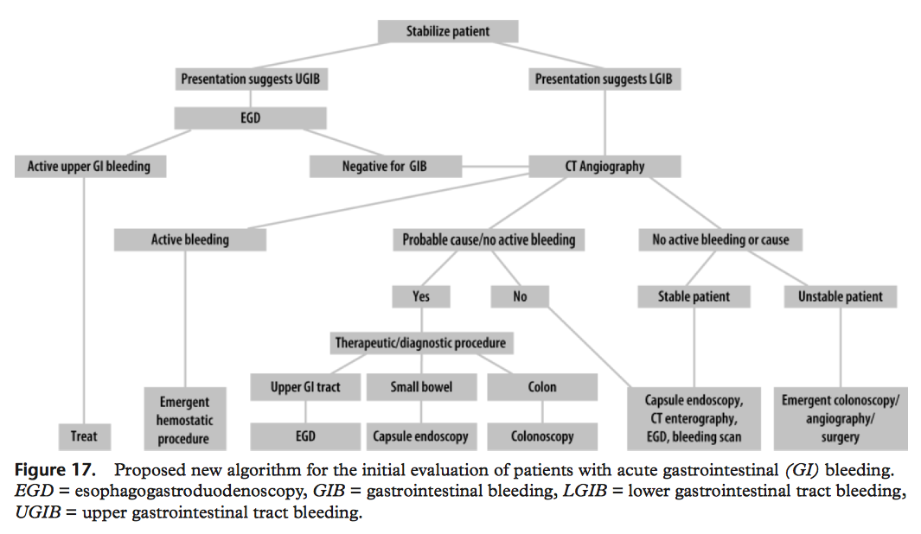

1. Zuckie LS, Acute gastrointestinal bleeding

Seminars Nuclear Medicine 2003; 33(4):297-311.

1. Yoon W. Jeang YY, Shin SS, etal. Acute massive gastrointestinal bleeding; detection and localization with arterial phase multi-detector row helical CT. Radiology/2006; 239

(1): 160-167.

1. Lee EW, Laborge JM. Differential diagnosis of gastrointestinal bleeding. Tech Vasc Interv Radiol/2005; 7:112-122
2. Rahn NH, Tishler JM, Han SY, Russenovich NA. Diagnostic and Interventional angiography in acute gastrointestinal hemorrhage. Radiology 1982. 143(2); 361-366.
3. Radiographics, Sept 2013, Vol. 33:1453-1470.

Department of Radiology

Hollis H. Halford Jr., MD

Chairman, Department of Radiology