What to do if PowerScribe goes down.

This message will appear indicating that PowerScribe is down.

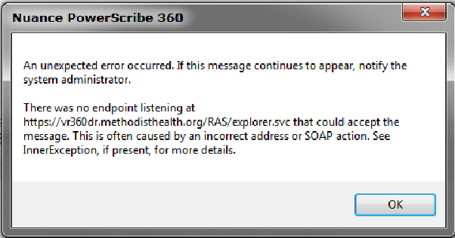

Call the IS help desk immediately so the Radnet team can be notified.

IN THE MEANTIME, stat and call reports need to be done manually.

The Radiologist will be notified when the failover system is up and running.

Logout of PACS, PowerScribe should auto logout, if not logout of PowerScribe.

On the PACS workstation, launch Internet Explorer



Somewhere on the favorites taskbar should be a PowerScribe 360 Downtime Icon.
(NOT SHOWN HERE!)


Click it.

Click RUN.

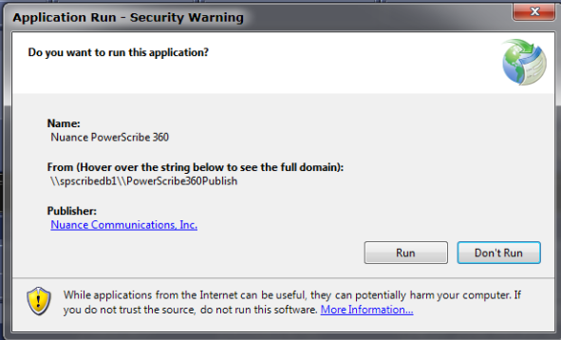

You will have to manually login to PowerScribe.

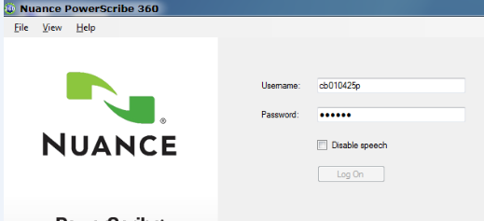

Once PowerScribe is up, login to PACS.
PACS will attempt to login to PowerScribe.
Since you are already logged into PowerScribe click DONT RUN.

Note: The backup PowerScribe system will not automatically launch the dictation once the images are opened. The accession number will have to be entered on PowerScribe. You can do this by typing, speaking, or wanding the accession number.

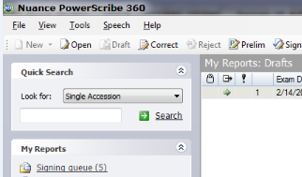

Click Search after entering the accession.

Dictate like normal. The report WILL interface with Cerner, display in PowerChart and print like usual.

IT will notify the Radiologists when the main PowerScribe system is up and operational.

Logout of PowerScribe and PACS.
Reboot the workstation.
Login normally and resume normally.

