How to dictate in PS360 during a Cerner or Interface downtime

1. Radiologists and Residents will dictate from both the Unread and the
Unspecified(VERIFIED EXAMS ONLY) worklists.
Or go to ALL EXAMS, enter a V in the status column to see both lists at the same time..

2. Open the PACS exam as usual.

3. PowerScribe MIGHT pop this message below.

4.. IF IT DOES: Type the first few letters of the exam that was performed.

5. Highlight the exam.
FYI: The order you pick drives what Auto Text opens.

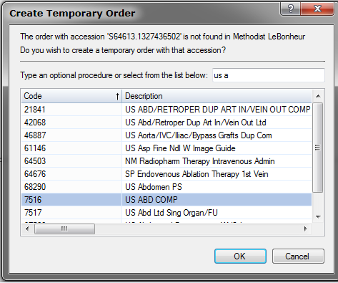

6.. Click OK.

7. Dictate normally. (Residents will have to choose a Radiologist).
(Residents will want to make a note in Powerscribe with the patient information so the Radiologist will have something to reference to search for images)
8. Before signing an ED STAT or Call Report: EITHER call the report, or
Copy and paste the report into a PACS Exam note.
(You will have to use the “Control V” button to paste into PACS)
ED Staff may need to be made aware to look in the exam note for the preliminary report.

9. Mark the exam dictated in PACS.

10. For questions please see your local RIS PACS Coordinator.

