Offline or Downtime for PowerScribe

A LITTLE BACKGROUND:
When an exam is ordered, that order is pushed also to PACS and PowerScribe.
When an exam is opened in PACS, PACS pushes the accession over to PowerScribe.
PowerScribe looks for the order and opens the report palette for dictation.

THE BENEFIT OF POWERSCRIBE:
Is that dictation CAN occur regardless if an order is present or not, this allows the Radiologist to dictate AS LONG AS POWERSCRIBE IS UP.

THE ORDER IS NOT IN POWERSCRIBE:
If for some reason the order is not present, PowerScribe will display the window below asking the user to create a temporary order for the exam to be dictated.

Search for the order you want here.

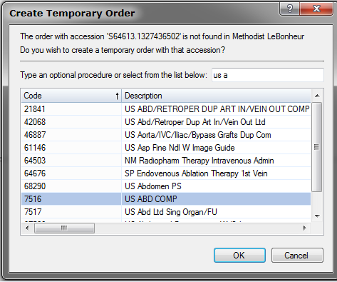

Highlight the order and click OK

*Remember, the auto text that opens will depend on the order that is selected.*

THE REPORT PALETTE OPENS:
Notice if the patient information is present. Depending on the situation, there could be some or none of the patient information present. For this example there is no patient information.

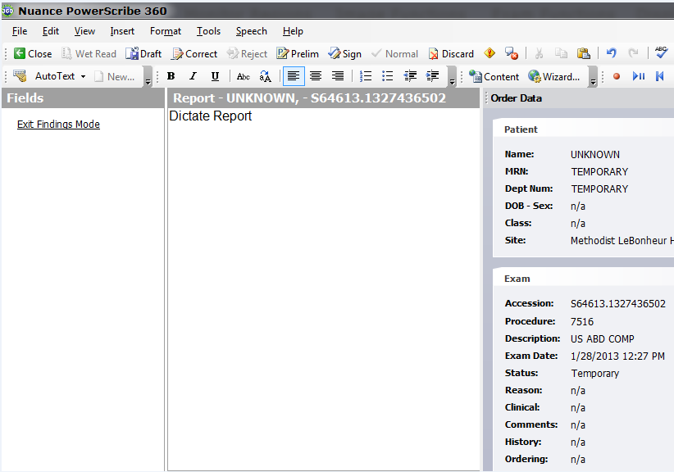
*If there is patient information present,, this next part is not relevant*

FOR THIS EXAMPLE since there is no patient information something will be needed to track and reconcile later the report to the actual patient. (The RIS PACS Coor will do the reconciling). If there is patient information present,, these options can be skipped.

There are two options.
- Dictate the patient information directly into the report itself.
- Use a note.

To use a note click on “Insert”, then “Note”

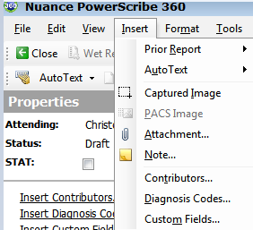
Once the Note window opens, enter the patient information and click OK.

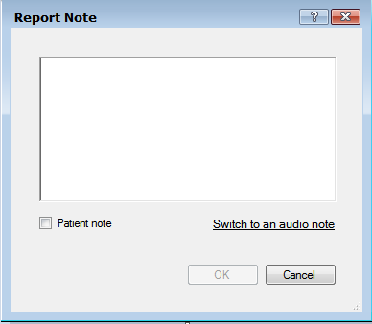

THE REPORT PALETTE IS READY FOR DICTATION.

DICTATE NORMALLY.

BEFORE YOU SIGN THE REPORT:
Since there is not a real order attached to the report it is important to remember that the report will ONLY live in Powerscribe. This means that the report is ONLY available for viewing by the Radiologist, which means critical results will need to be communicated.

TWO OPTIONS FOR REPORTING CRITICAL FINDINGS:
- Calling a report to the ED or physician.
- Placing the impression or report in the PACS Exam note.

TO COPY THE REPORT FROM POWERSCRIBE TO PACS:
Put the cursor at the beginning of the report.
Click and hold down the left mouse button, and highlight the report.
Once highlighted, release the left mouse button.
Make sure the cursor is within the highlighted area.
Single click the RIGHT mouse button, select COPY.

Open your PACS Exam note,
Place your cursor in the window and single click.
Press and HOLD DOWN the CONTROL key on your keyboard, then press ONCE the letter V key.
Your report is now pasted in the exam note.
Save the PACS exam note as you would normally.

SIGN YOUR REPORT IN POWERSCRIBE The exam in PACS MAY have to be marked dictated.

If you have any questions regarding what to do for offline reports or downtime, please contact your RIS PACS Coordinator, OR you may email me your questions at james.maxwell@mlh.org

